SKILLS FOR FREEDOM
Newsletter from India
No: 11 March: 2016

This electronic newsletter from PEACE TRUST, INDIA is addressed to NGO's, Social Activists, Media, Opinion makers, Leaders and Bureaucrats for improving their understanding on skilling the youth for gainful employment and addressing social issues like modern slavery, child labour, migrant labour, un-employability of youth. We also send this to people who we believe are involved in improving the migrant worker's conditions. You are welcome to unsubscribe yourself, if you so choose.
-EDITOR

Peace Trust is a Non Government Organization working on Child Labour and Bonded Labour issues since 1984. It has also focused on Migrant workers rights issue since 1999.

- Peace Trust’s Skills for Freedom is the only solution to end Modern Slavery in Tamil Nadu. It is a joint effort for enhancing the employment opportunities of rural youth in Dindigul, Karur, Tiruppur Districts.
- Reduce the risk for Young Workers - Beginning of this month Peace Trust has launched a new Initiative to "Support School Education, Health Protection, Livelihood Development and Skill Training for Gainful Employment among Vulnerable Young Population in Dindigul District".
- SPSC Vocational Education & Employment Facilitation Centre provides access to vocational education and employment facilitation for rural poor youth in Nagapattinam, Thiruvarur District Tamil Nadu and Karaikal District, Puducherry.
- Peace Trust also provides training for Quality Teacher Education and gainful employment to young women from resource poor families in Dindigul and Karur District.

The views expressed are not of the donors but a compilation of field realities for the purpose of sharing and action.

The Skills for Freedom e-newsletter is published by:

Peace Trust
Near Police Housing Colony
Trichy Road, Dindigul-624005,
Tamil Nadu, India
Ph:0451-2410021; Fax:0451-2410372
Email: info@peacetrust.in , chairman@peacetrust.in
Website: www.peacetrust.in
Edited By: Dr. J. Paul Baskar Ph.D.
Assisted By: Ms. Anitha Palanivel, Mrs. Chitra

We partner with

NABARD PLANS DIGITISATION OF SHGS
National Bank for Agriculture and Rural Development (NABARD) has plans for digitisation of all self-help groups in two districts as a pilot project for easy access to wide range of financial services and to ensure transparency in the SHGs and their financial transactions, quick credit appraisal and disbursement, according to K. Venkateswara Rao, Chief General Manager, NABARD. Talking to The Hindu at Dharmathupatti village near here on Thursday, he said that Salem and Dharmapuri were identified for implementing this pilot project. Data of all SHGs and their members in these districts would be created.
Individual data linking their Aadhar and mobile numbers would also be included. All the data would be available in the mobile sets or tabs of SHG members. The members and groups would update all their transactions periodically. “Banks would be given viewing rights of their activities. Such measure would help banks view the groups’ activities and sanction loans through their branches quickly,” he added.
Digitisation software would be developed in regional languages. Ultimately it would benefit rural members of the SHGs. In 1993, Tamil Nadu had just 500 groups. Now it had 9.5 lakh groups, he said. NABARD also planned to launch livelihood entrepreneurship development project in Kanyakumari, Pudukottai and Cuddalore in Tamil Nadu and Puducherry in order to generate better livelihood activities of the poor.
A total of 142 farmer producer organisations (FPOs) had started functioning in the State, of which 45 had registered as companies and the remaining were at various stages. “Initially, we had planned to set up 162 FPOs in the State. The FPOs will reduce middlemen in marketing and enhance profit margin of the farmers,” Mr. Rao noted. A special fund would be sanctioned by the Centre to each FPO on a par with their capital amount.
Moreover, the Centre would offer Rs. 1 crore credit guarantee to the FPOs. NABARD had funded four FPOs in Salem, Nagapattinam and Tiruvannamalai districts as pilot projects.
Moreover, NABARD had planned to invest Rs. 1.71 lakh crore in priority sector in the next fiscal.
CHILD RIGHTS
SATYARTHI URGES GOVT. TO INVEST MORE ON CHILDREN IN BUDGET
Though children below 18 years of age constitute 41 per cent of the country’s population, the budgetary allocation for them remains dismal, child rights campaigner and Nobel Laureate Kailash Satyarthi said here on Saturday.
Urging the Union government to invest more on children in the coming Union budget, he said: “India is proud of being the youngest society in the world… We all talk about demographic dividend but when it comes to investment on children, on their health, education and protection, it is dismal I would say. This is only four per cent or less of the budget on children health education and protection.” Interacting with journalists at the Kolkata Press Club, Mr. Satyarthi said no country could accomplish inclusivity and sustain development, along with social development and peace, unless it gave priority to the health and education of its children.
Speaking on the proposed amendments to the existing law on child labour, he expressed the hope that Parliament would pass a progressive law. “We demand that child labour be completely prohibited up to 14 years of age and employment of children be prevented in any hazardous profession between 15 to 18 years of age,” he said.
While the existing law identified 83 hazardous occupations prohibiting children from working, Mr. Satyarthi said the proposed amendment reduced the number of hazardous occupations only to three.
The child rights activist said he would soon launch a campaign ‘100 million for 100 million’. A 100 million children who are in schools and colleges and have access to education and other facilities will make a difference to the other 100 million who are not so fortunate, he said.
The campaign would be both online and on the ground and he was trying to reach the media groups and universities. Though he refrained from giving a direct answer to the recent developments at the Jawaharlal Nehru University, he said youths all over the world were getting frustrated and disillusioned with institutions.

HUGE BUDGET CUT FOR ICDS
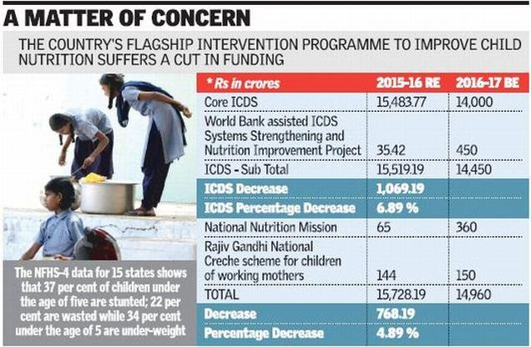
For the second year in a row, the Modi government has reduced fund available to child health interventions, with a massive cut — from Rs. 15,483.77 crore last year to Rs. 14,000 crore in the latest budget.
The National Family Health Survey (NFHS)-4 data for 15 States shows that 37 per cent of children under the age of five are stunted; 22 per cent are wasted while 34 per cent under the age of 5 are under weight.
The Integrated Child Development Scheme (ICDS) has seen a 7 per cent reduction in fund. The scheme, implemented by the Women and Child Development (WCD) Ministry, is the country’s flagship intervention to improve child nutrition in the country. “This is the largest programme in the world for children and the ICDS is fundamental to marginalised children in India,” said Thomas Chandy, Chief Executive Officer of Save the Children.
That’s not all — the percentage share of the Mid-Day Meal (MDM) scheme in the total Union Budget allocation has gone down from 0.74 per cent in 2014-15 (BE) to 0.49 per cent in 2016-17 (BE). The allocation for the MDM scheme for 2016-17 stands at Rs. 9,700 crore (2016-17 BE). The budget comes a week after the Economic Survey states that India needed to increase investments on child nutrition programmes if it were to capitalise on the demographic advantage offered by its young population.
The total amount spend on child health by the government would be Rs. 65,758 crore. Over the last two years, allocations for ICDS have seen a sharp decrease, maintain experts.

TEA PLANTATION
TAMIL YOUTHS IN SRI LANKA MOVING OUT OF PLANTATION SECTOR
Tamil youths living in plantations of Sri Lanka are increasingly moving out of the estate sector. The youths belong to the ethnic group called Indian Tamils or Tamils of recent Indian origin.
The estate sector consists of the State-owned plantations which comprise over 1,70,000 hectares, most of which is devoted to tea and rubber cultivation. The plantations were originally set up by the British colonists in the central parts of Sri Lanka. Between the middle of 19{+t}{+h}century and the early 20{+t}{+h}century, mostly people from Tamil Nadu were brought in to work in the estate sector.
A recent study of the World Bank stated that in the plantations during the period between 2003 and 2012, the number of youths of 15 years to 24 years declined. This was more so in the case of the group of 15 years to 19 years.
The average annual rate of change or growth was of the order of about minus four per cent for the age group of 15-19 years and around minus one per cent for the group of 20-24 years.
Lack of formal education
Another indicator was that not even 50 per cent of the youths of the age group of 15 years to 20 years pursued formal education. The figure was 49 per cent as against the country’s overall 66 per cent.
In contrast to the falling number of youths in the plantations, the share of senior citizens — those aged 60 years and above — went up by eight per cent annually on an average.
S. Chandrasekaran, a former professor of education and a member of the ethnic group, says it is well known that the present-day youths regard working in the plantations as inferior to their social status and they prefer to take up any work in urban areas.
The World Bank also brought out difficulties being faced by the educated youths from the plantations in getting salaried employment outside the estate sector.
Even though opportunities for them are expanding in the sector of services such as retail stores and communication centers, the scope in professional, salaried occupations is not “easily available.” Quoting a research work, the Bank’s document pointed out that the “estate youths” have to compete with better educated peers who are preferred by employers. They are also facing “stigmatization and discrimination due to their Indian Tamil ethnicity and estate worker identity, both of which constitute a barrier in accessing non-estate job opportunities.” Consequently, the youths accept lower level job openings — domestic workers, shop assistants or construction workers — and relatively a few are able to secure jobs as semi-skilled workers, such as drivers or mechanics, the report added.

HUMAN RIGHTS
INDIAN PHILANTHROPISTS SHOULD SUPPORT HUMAN RIGHTS ACTIVISM

Henri Tiphagne, the first Indian chosen by Amnesty International for its Human Rights Award, feels that time has come for Indian philanthropists to support hardcore human rights activism.
Amnesty International announced on January 25 that the 8{+t}{+h}Human Rights Award would be conferred on Mr. Tiphagne, executive director of Madurai-based People’s Watch, on April 25 at Maxim Gorki Theatre, Berlin, in recognition of his “exceptional commitment to human rights.”
“Henri Tiphagne and his organisation People’s Watch, while fighting to ensure the rights of others, are themselves being harassed and hampered in their work by the authorities. And there are other civil society organisations in India that are in a similar position. The award is therefore meant to send a strong signal of support to the whole of the Indian human rights movement,” said Selmin Caliskan, Director of Amnesty International Germany, in a statement.
Recounting his tryst with human rights activism, Mr. Henri says that he entered the arena when ‘human rights’ was treated as a “bad word.” There were at least two occasions when he wanted to resume his profession as a lawyer when the government closed the funding channels.
“But I realised that defending human rights outside courts was my calling. When all these attacks on human rights defenders are taking place, I feel comforted that I have made the right option, though a painful option,” he says.
“The Amnesty International Award is not for an individual but for all Indian human rights defenders, who are functioning under terrible restrictions even on protest and dissent. It is also for my mentors like K. Balagopal and K.G. Kannabiran who lived when award culture was not there for the type of work they did,” says Mr. Tiphagne.
“In the modern context, foreign investment for industries is welcome but any funding to protect the rights of people is looked at with suspicion,” he notes.
The award, presented once in two years, is endowed with 10,000 Euros. The recipients of the award include Monira Rahman of Bangladesh (2006), Women of Zimbabwe Arise (2008), Abel Barrera of Mexico (2011) and Alice Nkom of Cameroon (2014).

MIGRANTS
OVER 131,000 MIGRANTS REACHED EUROPE BY MEDITERRANEAN SEA IN 2016: UNITED NATIONS
Out of a total of 131,724 people who have arrived on Europe's shores this year, 122,637 landed in Greece.
More than 131,000 migrants and refugees have reached Europe via the Mediterranean this year, more than the total number in the first five months of 2015, the United Nations said on Tuesday.
Out of a total of 131,724 people who have arrived on Europe’s shores this year, 122,637 landed in Greece and most were fleeing the conflict in Syria, the UN’s refugee agency (UNHCR) said.
The agency said an estimated 24,000 migrants in Greece were in need of accommodation as of last night.
Huge blockages of people have built up in the country after European nations including neighboring Macedonia set tight limits on migrants entries.
“Europe is on the cusp of a largely self-induced humanitarian crisis,” the agency warned, accusing EU governments of fuelling the chaos and suffering by resorting to “inconsistent practices” in response to the migrant influx.
MIGRANTS OCCUPY SHANTY ROOFTOPS TO PROTEST CALAIS DEMOLITION
The slow tear-down of the encampment in Calais has angered migrants who live there in squalid conditions in hopes of reaching a better life in Britain.
About two dozen people protesting the demolition of a sprawling migrant camp in northern France climbed onto shanty rooftops on Tuesday and were surrounded by a police cordon. A man and a woman standing together on a rooftop warned police not to approach. The woman then cut her wrists as officers moved forward. Baton-wielding police beat the man and both were removed from the roof. The woman was conscious, but her condition wasn’t immediately known.
The slow tear-down of the encampment in Calais has angered migrants who live there in squalid conditions in hopes of reaching a better life in Britain. France’s government, which has offered to relocate uprooted migrants into heated containers or at centers around France where they can decide whether to apply for asylum, blamed activists from the group No Borders for the ongoing unrest. But many migrants resist French offers of help, afraid of hurting their chances to reach Britain. The city bordering the Channel has ferry links and the Eurotunnel rail to England, and is temporary home to an estimated 4,000 migrants, down from 6,000 in December. The camp has become a flashpoint between France and Britain, fueling far-right support in both countries. “This operation will continue in coming days, calmly and methodically, providing a place for everyone as the government has committed,” French Interior Minister Bernard Cazeneuve said in a statement Tuesday.
BONDED LABOURERS
CID RESCUES 15 BONDED LABOURERS
Bengaluru: The Anti-Human Trafficking Unit (AHTU) of the Criminal Investigation Department (CID) and an NGO rescued 15 bonded labourers from a sugarcane field in Bagalkot district, north Karnataka, on Monday. The rescued workers included four boys, four girls and an eight-month-old infant.
Investigation revealed the victims are from Madhya Pradesh and a middleman contacted them in mid-2015, saying he could get them dailywage work. First, they were taken to construction sites in Maharashtra.
"After construction was over, the same middleman promised them a monthly salary of Rs 20,000 for the group and brought them to Petlur village in Bagalkot district.Though they toiled in the sugarcane fields from dawn to dusk, they were not paid at all," said Sonia Narang, DIGCID, who led the operation.
All the rescued persons were sent to Madhya Pradesh.CID police arrested landowners Lakshman Gouda Patil and Shankarappa Basappa Yadahalli, both around 50, and residents of Petlur as well as agent Purushottam Rohidas Kokate.
Police are looking for the prime accused, the man who brought the workers from Madhya Pradesh.
Sonia said one of the victims managed to call his father, saying they had been illegally detained. "The father approached Jan Sahas, an NGO in Madhya Pradesh. Jan Sahas and the International Justice Mission approached us with the complaint," CID police said.
CID-DG Kishore Chandra told TOI he formed a team led by Sonia. "One batch visited the village and confirmed the confinement. We rushed rescue teams to the sugarcane field on Monday," she said, adding, "They were given meager amount of food. When they asked for their wages, the accused would beat them," she said.
Esther Daniel, director, International Justice Mission, said: "Under Section 370 of the Indian Penal Code, human trafficking can attract a minimum sentence of seven years. The Bagalkot rescue shows us what is possible when there is a convergent approach to such crimes."

TEAM TO PROBE KILN WORKERS' CHARGE OF BONDED LABOUR
Bathinda: After three days of protests by brick kiln labourers and a fast unto death started by the convener of NGO Volunteers for Social Justice (VSJ), the district administration agreed to send a team of officials to a brick kiln at the nearby Mehraj village to check human rights violations.
Bathinda deputy commissioner Basant Garg on Saturday afternoon reached the dharna (sit-in) site and assured complete justice to the labourers.
He told them about sending a team, led by an additional deputy commissioner-rank officer, to the brick kiln. Earlier, on Friday evening, VSJ convener Jai Singh had started a fast unto death at the B R Ambedkar statue in the town. Suspecting unrest at the protest site, police were deployed near the statue.
The brick kiln labourers have been protesting for the past three days, alleging that the brick kiln owner had not paid them wages for nearly a month and had forcibly kept some of their colleagues at the kiln in Mehraj. Bathinda deputy commissioner Garg said, "Two spot inquiries have already been conducted. Now, on the demand of workers, another team led by an ADC has been sent to the kiln to see if there is any violation of Supreme Court guidelines and look for captive labourers."
Forty workers, who belong to eight families, were brought from Uttar Pradesh in October by advancing Rs 5,000 to each as loan, the workers have claimed.
The brick kiln owner, it has been claimed, is demanding the remaining amount of the unpaid debt before letting the captive workers go. Each laborer’s family owes Rs 600 to Rs 700 to the employer.
BONDED LABOUR EMPLOYERS GO FREE AS PROBES SLOW DOWN
Recent rescues of bonded labourers from brick kilns and rice mills in Kancheepuram and Tiruvallur have thrown up a shocking fact ­ despite cases filed under stringent laws, employers wriggle out and continue to employ bonded labourers in the same location.
This was evident last Wednesday when the Ponneri Revenue Divisional Officer and police rescued more than 500 people from a brick kiln unit which had been raided in 2011. District officials said the owner of the unit had been arrested in 2011 for employing bonded labourers from Chhattisgarh. Sources in the district administration admit that he managed to get bail due to slow investigation by police and resumed exploiting migrant labourers.
A similar case occurred ast month in Chengalpet when bonded labourers were rescued from the same rice mill in two separate raids in the space of a month.
A Kancheepuram district administration official said tardy investigation and delay in filing chargesheets allowed the perpetrators to go free. “If the investigation is not completed within three months, the accused get statutory bail from co urt,“ he said. Despite being booked under SCST (Prevention of Atrocities) Act, the accused managed to escape, he added.
Kural Amuthan, director at International Justice Mission (IJM), an NGO which assists in rescue missions, said police viewed bonded labour as a labour issue and not as a problem of human trafficking which is internationally classified as organised crime. “The investigation is not done with the same vigour as a rape or murder case which have the same penalty , that is, seven years to life imprisonment,“ Amuthan said.
The victims are mostly from oppressed classes and given the feudal relationship with their `owners', shy away from seeking legal representation and fear testifying against their oppressors, Amuthan added. “This is also one of the reasons why freed bonded labourers go back and work in the same environment. If the owner is in jail, the other actors in the crime chain like middlemen and contractors threaten them,“ said Richard Ebenezer, an advocate practising in the Madras high court.
The Centre is also planning to increase the rehabilitation amount for the rescued labourers from `20,000 to ``2 lakh but with a caveat that the money reaches the victims only after prosecution. “How can victims restart their lives if perpetrators are allowed to go scot free?“ Amuthan said.
NHRC notice to TN
Chennai: The National Human Rights Commission (NHRC) has sought a report from the Tamil Nadu government on the rescue of 550 bonded labourers from a brick manufacturing unit in Tiruvallur district recently.The NHRC has asked the government to specify the steps taken to rehabilitate the labourers.
YOUNG WOMEN WORKER'S CONVENTION - 2016
Young Women worker’s Convention was conducted for the young adolescent girls on March 3rd, 2016 in Dindigul Vanniyar Community Hall. Mr. Bala Murugan and Mr. Jaleel Program Manager, Geneva Global has presided over the meeting. Mr. Henry Sahayaraj has welcomed the participants. Dr. J. Paul Baskar gave the presidential address and explained about the status of the young workers. Mr. Anna Durai, Managing Trustee, Child Voice has explained about the role of NGOs in working for young workers rights. Mr. Jayaraman, Mr. Jeyamani from INTUC and Ms. Fareetha Begam has participated in the convention.
More than 100 adolescent girls who are working spinning mills participated in the convention and expressed their demands to be included in the election manifesto of the political parties. Young workers major demands were; to arrange bus facilities, public toilets, drinking water, safety in working area and medical shop facilities. They also requested to stop child marriages and to eradicate child labour. Mr. Srinivasan, Project Manager has proposed the vote of thanks.

VACCINATION FOR THE GIRLS BY PUBERTY AND THE IMMUNITY LEVEL OF THE WOMEN AT DIFFERENT STAGES
A one day awareness programme on “Vaccination for the girls by puberty and the immunity level of the women at different stages” was conducted in Peace College of Education on 18 February, 2016 by Peace Trust-Young Workers Project in collaboration with Mother Terasa Women’s University, Dindigul.
Mrs. Uma Maheshwari, Assistant Professor of Department and Centre for Women’s Studies (DCWS), Mother Terasa Women’s University has provided the welcome address. Dr. J. Paul Baskar, Chairman, Peace Trust has given the presidential address. Mr. Bala Murugan and Mr. Jaleel, Programme Managers, Geneva Global has given a special address about the health awareness to young adolescent girls. Dr. S.P. Denisia, Professor and Director, DCWS, Mother Terasa Women’s University has provided the thematic address. Dr. S. Meena Priya Dharsini, Assistant Professor, DCWS, MTWU has explained about the importance of the health. Ms. Uma Maheshwari has explained about the importance of the vaccination for girls. Ms. Punithavathi, Project Associate, DCWS, MTWU has briefly explained about the Nutrition and Immunization. Mrs. Pavithra, field coordinator of Young Workers Project has delivered the vote of thanks.
JUSTICE V.R. KRISHNA IYER AWARD FUNCTION
The Justice V.R.Krishna Iyer Centenary Award function was conducted on 20th February, 2016 at 10.00am at Bharath Hotel, Ernakulam, Kerala, organized by the Society for Community Organisation Trust, Justice Bhagwati Bhavan, Madurai in the presence of Mr. A. Mahaboob Batcha, Managing Trustee, SOCO Trust. The special invitees are Hon’ble Mr. Justice Dama Seshadri Naidu, Judge, High Court of Kerala and Hon’ble Ms. Justice Anu Sivaraman, Judge – High Court of Kerala. The presentation ceremony for those who are worked in Social Justice and Human Rights. The Hon’ble Justice Dama Seshadri Naidu and Anu Sivaraman to present the awards to Ms. Mary Roy, Founder of Pallikoodam & Women Rights Activist, Dr. Sugatha Kumari, Poet Environment Activist, Prof.Sarah Joseph, Writer and Activist, Dr.Kuruvilla Varky M.D., Christian Fellowship Hospital, Mr.Ponneelan, Writer and Sahhithya Academy Awardee, Dr.Jacob Vadakkanchery, Foundar of Nature life International, Mr.G.Jeyaseelan FCA, Chartered Accountant, Mr.S.Balamurugan, Advocate and Writer and Mr. K.V. Prakash, Advocate and Documentary Film Director. Dr. J. Paul Baskar, Chairman, Peace Trust was awarded V.R. Krishna Iyer Centenary Award for his combined contribution through Peace Trust to eliminate Child Labour, improve condition of Young Workers, Protect environment, and Provide Skill Training to Youth.
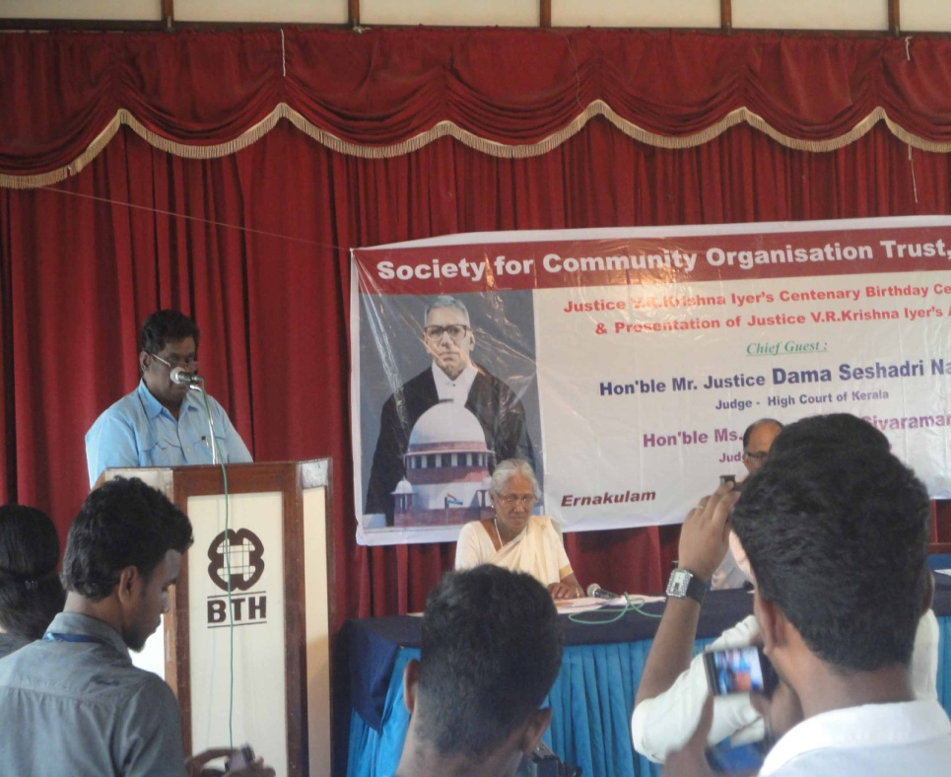
Dr. J. Paul Baskar speaks at Justice V.R. Krishna Iyer Centenary Award Function, Cochin, Kerala.

EXPOSURE VISIT TO LITTLE FLOWER ENGINEERING INSTITUTE, ERNAKULAM
Dr. J. Paul Baksar, Chairman, Peace Trust, Mrs. Josephine Mercy, Principal of Peace ITI, Director of Peace Trust and the staffs from Peace Trust have went to an exposure visit to Little Flower Engineering Institute in Ernakulam, Kerala. Little Flower Engineering Institute (LFEI) has secured the prestigious Centre of Excellence National Award instituted by SKIP (Skill for Progress), an association with its headquarters at Bangalore, constituting a network of member ITCs from all over India in recognition of the excellence in technical and vocational training. This award has been in recognition of its admirable progress and innovation in the field of Technical and Vocational Training in India. The institute is approved for National Council for Vocational Training (NCVT). The Institute has 6 two year course, 2 one year course and 3 short term job oriented courses. The exposure visit was helpful for participants for improving the quality, standard individually as well as Institute level.

